- Layers in OSI model: PDNTSPA
- To show all shortcuts in eclipse: Ctrl + Shift + L
- Always select the code and use Ctrl + I for indentation.
- (Learn this list) Java’s Checked Exceptions Defined in java.lang that must be appear in any method’s throws list if it doesn’t handle that exception itself:
ClassNotFoundException,
CloneNotSupportedException,
IllegalAccessException,
InstantiationException,
InterruptedException,
NoSuchFieldException,
NoSuchMethodException,
ReflectiveOperationException,
- Java’s Unchecked RuntimeException Subclasses Defined in java.lang that need not to be appear in any method’s throws list because the compiler does not check to see if a method handles or throws these exceptions:
StringIndexOutOfBounds,
ArithmeticException,
ArrayIndexOutOfBoundsException,
ArrayStoreException,
ClassCastException,
EnumConstantNotPresentException,
IllegalArgumentException,
IllegalMonitorStateException,
IllegalStateException,
IllegalThreadStateException,
IndexOutOfBoundsException,
NegativeArraySizeException,
NullPointerException,
NumberFormatException,
SecurityException,
TypeNotPresentException,
UnsupportedOperationException,
- The exception hierarchy is:
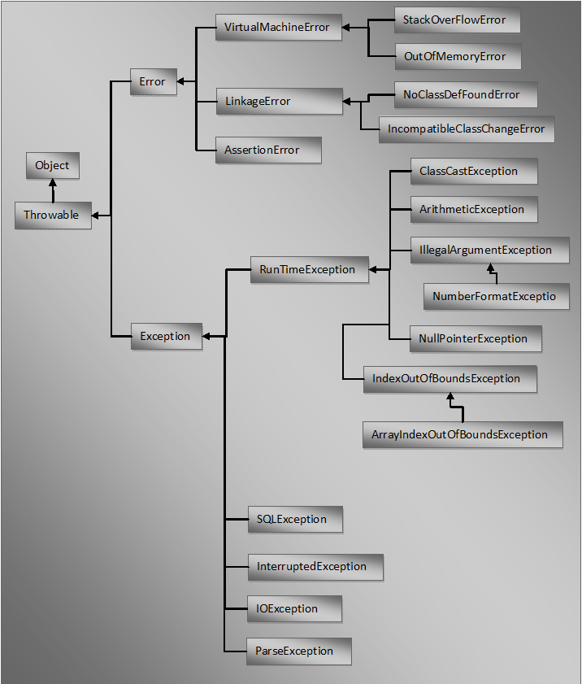

- java.util.Collection is the root interface in the hierarchy of Java Collection framework in java.
There are two groups of interfaces related to collections: Collection and Map.
Map interface is a member of the Java Collections Framework, but it does not implement Collection interface in java.
Collection inherits Iterable interface.
Maps doesn’t inherit iterable intreface.

Collection- List, Set, Queue,
List- ArrayList, LinkedList, Vector, Stack,
Set- EnumSet, HashSet, LinkedHashSet, TreeSet,
SortedSet- TreeSet,
NavigableSet- TreeSet,
Queue- LinkedList, PriorityQueue
Deque- ArrayDeque, LinkedList
Map- HashMap, TreeMap, HashTable, EnumMap, IdentitiHashMap, LinkedHashMap, Properties, WeakHashMap,
SortedMap- TreeMap,
NavigableMap- TreeMap,
BlockingQueue (Concurrent Queue Implementation)- LinkedBlockingQueue, ArrayBlockingQueue, PriorityBlockingQueue, DelayQueue, SynchronousQueue,
ConcurrentMap- ConcurrentHashMap (concurrent analog of HashMap, an alternative of HashTable),
ConcurrentNavigableMap- ConcurrentSkipListMap (concurrent analog of TreeMap),
ConcurrentNavigableSet- ConcurrentSkipListSet (concurrent analog of Treeset),

Core classes and interfaces in java.util.List hierarchy:
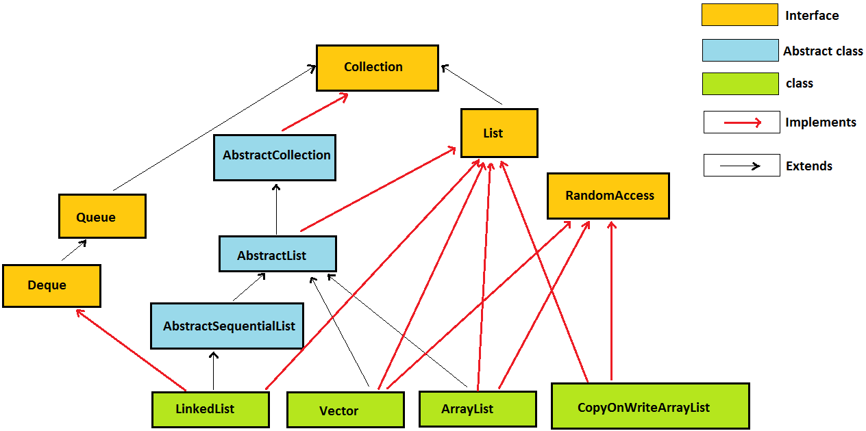
Core classes and interfaces in java.util.Set hierarchy:
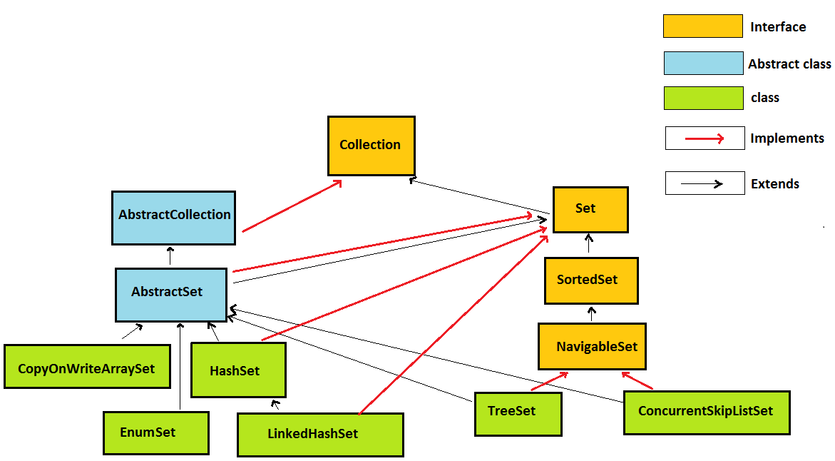
Core classes and interfaces in java.util.Map hierarchy:
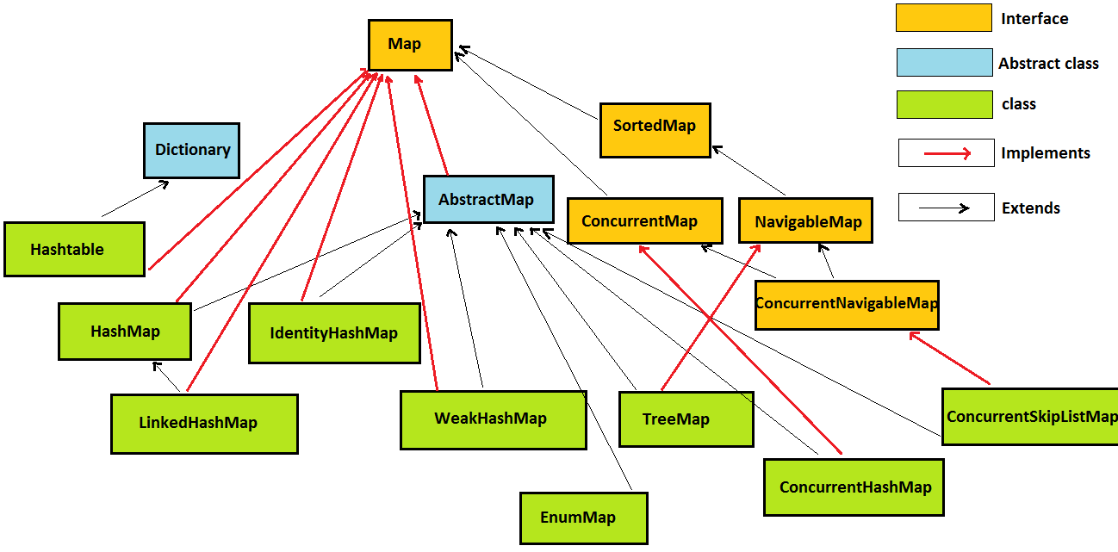
- Always try to implement a method in such a way, so that it can be reused by passing some other similar behavior:
For example see the following method:
public int sumAll(List<Integer> numbers, Predicate<Integer> p) {
int total = 0;
for (int number : numbers) {
if (p.test(number)) {
total += number;
}
}
return total;
}
This method can be called as following:
sumAll(numbers, n -> true); // gives the sum of all elements
sumAll(numbers, n -> n % 2 == 0); // gives the sum of only even elements
sumAll(numbers, n -> n > 3); // gives the sum of all elements > 3
Always think if a method can be implemented like this. This reduces code duplication.
- Does Thread implements their own stack? If yes, how?
Yes, Threads have their own stack. This is very interesting question, where interviewer tends to check your basic knowledge about how threads internally maintains their own stacks. I’ll be explaining you the concept by diagram.
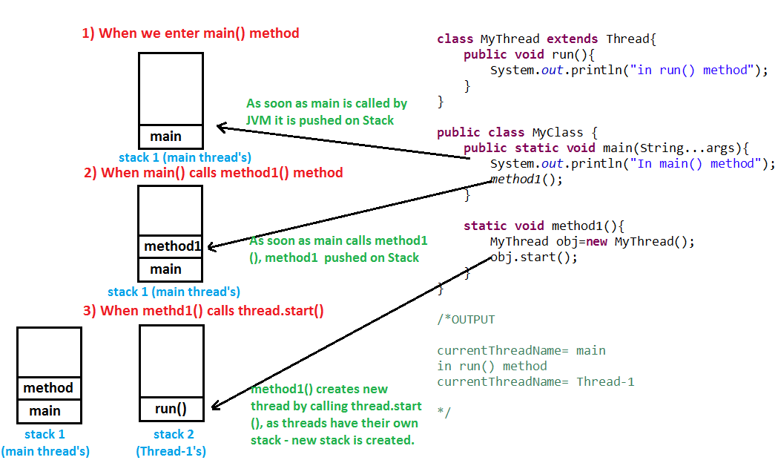
- How can you say that the behavior of thread is unpredictable?
The solution to question is quite simple, Thread behaviour is unpredictable because execution of Threads depends on Thread scheduler, thread scheduler may have different implementation on different platforms like windows, unix etc. Same threading program may produce different output in subsequent executions even on same platform.
- When threads are not lightweight process in java?
Threads are lightweight process only if threads of same process are executing concurrently. But if threads of different processes are executing concurrently then threads are heavy weight process.
- Give a simple example of deallock.
Thread-1 acquires lock on String.class and then calls sleep() method which gives Thread-2 the chance to execute immediately after Thread-1 has acquired lock on String.class and Thread-2 acquires lock on Object.class then calls sleep() method and now it waits for Thread-1 to release lock on String.class.
Code called by Thread-1
public void run() {
synchronized (String.class) {
Thread.sleep(100);
synchronized (Object.class) {
}
}
}
Code called by Thread-2
public void run() {
synchronized (Object.class) {
Thread.sleep(100);
synchronized (String.class) {
}
}
}
Conclusion:
Now, Thread-1 is waiting for Thread-2 to release lock on Object.class and Thread-2 is waiting for Thread-1 to release lock on String.class and deadlock is formed.

Here comes the important part, how above formed deadlock could be solved:
Code called by Thread-1
public void run() {
synchronized (String.class) {
Thread.sleep(100);
synchronized (Object.class) {
}
}
}
Code called by Thread-2
public void run() {
synchronized (String.class) {
Thread.sleep(100);
synchronized (Object.class) {
}
}
}
Conclusion: No deadlock is formed.
- Few important measures to avoid Deadlock:
- Try to lock specific member variables of an object rather than locking whole object.
- Use join() method: If possible try to use join() method, although it may refrain us from taking full advantage of multithreading environment because threads will start and end sequentially, but it can be handy in avoiding deadlocks.
- If possible try avoid using nested synchronization blocks.
- Have you ever generated thread dumps or analyzed Thread Dumps?
Answering this questions will show your in depth knowledge of Threads. Every experienced must know how to generate Thread Dumps.
VisualVM is most popular way to generate Thread Dump and is most widely used by developers. I’ll recommend every developer must understand this topic to become master in multi threading. It helps us in analyzing threads performance, thread states, CPU consumed by threads, garbage collection and much more. For detailed information see Generating and analyzing Thread Dumps using VisualVM - step by step detail to setup VisualVM with screenshots
jstack is also very easy way to generate Thread dump and is widely used by developers. For creating Thread dumps we need not to download any jar or any extra software. For detailed information see Generating and analyzing Thread Dumps using JSATCK - step by step detail to setup JSTACK with screenshots.
- Similarities beween wait() and sleep() method:
Both are native method (By the way, notify() and notifyAll() are also native method). The implementation of all these is provided by JVM.
Differences beween wait() and sleep() method:
  - Should be called from synchronized block : wait() method is always called from synchronized block i.e. wait() method needs to lock object monitor before object on which it is called. But sleep() method can be called from outside synchronized block i.e. sleep() method doesn’t need any object monitor.
  - Exception: If wait() method is called without acquiring object lock than IllegalMonitorStateException is thrown at runtime, but sleep() method never throws such exception because sleep() method have nothing to do with monitor. sleep() method throws compile time exception i.e. InterruptedException.
  - Belongs to which class : wait() method belongs to java.lang.Object class but sleep() method belongs to java.lang.Thread class.
  - Static or Instance: sleep() method of Thread class is a static method where as wait() method in Object class is a non-static method.
  - Called on object or thread : wait() method is called on objects but sleep() method is called on Threads not objects.
  - Thread state : when wait() method is called on object, thread that holded object’s monitor goes from running to waiting state and can return to runnable state only when notify() or notifyAll() method is called on that object. And later thread scheduler schedules that thread to go from from runnable to running state.
when sleep() is called on thread it goes from running to waiting state and can return to runnable state when sleep time is up.
  - When called from synchronized block : when wait() method is called thread leaves the object lock. But sleep() method when called from synchronized block or method thread doesn’t leaves object lock.
- Salient features of yield() method:
  - Definition : yield() method when called on thread gives a hint to the thread scheduler that the current thread is not doing something very important and can leave the processor for some other thread. The thread scheduler is free to ignore this hint.
  - Thread state : when yield() method is called on thread it goes from running to runnable state, not in waiting state. Thread is eligible to run but not running and could be picked by scheduler at the discretion of the implementation.
  - Exception : yield() method doesn’t throws any exception.
  - Waiting time : yield() method stops thread for unpredictable time.
  - Static method : yield() is a static method, hence calling Thread.yield() causes currently executing thread to yield.
  - Native method : implementation of yield() method is provided by JVM.
  - synchronized block : thread need not to to acquire object lock before calling yield() method i.e. yield() method can be called from outside synchronized block.
  - Belongs to which class : yield() method belongs to java.lang.Thread class.
- Can threads read the segment locked by some other thread in ConcurrentHashMap?
Yes. When thread locks one segment for updation it does not block it for retrieval (done by get method) hence some other thread can read the segment (by get method), but it will be able to read the data before locking.
- Can we acquire lock on class? What are ways in which you can acquire lock on class?
Yes, we can acquire lock on class’s class object in 2 ways to acquire lock on class.
Thread can acquire lock on class’s class object by-
  - Entering synchronized block:
synchronized (MyClass.class) {
//thread has acquired lock on MyClass’s class object.
}
  - by entering static synchronized methods:
public static synchronized void method1() {
//thread has acquired lock on MyRunnable’s class object.
}
- What is executor framework?
- Executor and ExecutorService are used for following purposes >
  - creating thread,
  - starting threads,
  - managing whole life cycle of Threads.
- Executor creates pool of threads and manages life cycle of all threads in it.
- In Executor framework, Executor and ExecutorService interface are most prominently used.
- Executor interface defines very important execute() method which executes command.
- ExecutorService interface extends Executor interface.
- ExecutorService interface provides following type of methods >
  - methods for managing termination and
  - methods that can produce a Future for tracking progress of tasks.
- What is busy spin?
When one thread loops continuously waiting for another thread to signal, this is called busy spin.
Performance point of view - Busy spin is very bad from performance point of view, because one thread keeps on looping continuously ( and consumes CPU) waiting for another thread to signal.
Solution to busy spin -
We must use sleep() or wait() and notify() method. Using wait() is better option.
Consumer Producer problem with busy spin > see project ProducerConsumerSimple
- Is Java a pure object oriented language? if not why? (answer)
Java is not a pure object-oriented programming language e.g. there are many things you can do without objects e.g. static methods. Also, primitive variables are not objects in Java.
- Can we overload a static method in Java?
Yes, you can overload a static method in Java. You can declare as many static methods of the same name as you wish provided all of them have different method signatures.
- Can we override static method in Java?
No, you cannot override a static method.
- Can we prevent overriding a method without using the final modifier?
Yes, you can prevent the method overriding in Java without using the final modifier. In fact, there are several ways to accomplish it e.g. you can mark the method private or static, those cannot be overridden.
- How can you implement your own Thread Pool in java?
ThreadPool is a pool of threads which reuses a fixed number of threads to execute tasks. At any point, at most nThreads threads will be active processing tasks. If additional tasks are submitted when all threads are active, they will wait in the queue until a thread is available. ThreadPool implementation internally uses LinkedBlockingQueue for adding and removing tasks.
For own Thread Pool in java: See project ThreadPool.
- What are the differences between equals() method and ‘==’ operator in java?
- equals() is a method and “==” is an operator.
- Since Java doesn’t support operator overloading, == behaves identical for every object but equals() is method, which can be overridden in Java and logic to compare objects can be changed based upon business rules.
- Another notable difference between == and equals method is that former is used to compare both primitive and objects while later is only used for objects comparison.
- In terms of comparing primitives like boolean, int, float "==" works fine but when it comes to comparing objects it creates confusion with equals method in Java. "==" compare two objects based on memory reference. so "==" operator will return true only if two object reference it is comparing represent exactly same object otherwise "==" will return false.
Default implementation of equals provided in Object class is similar to "==" equality operator and return true if you are comparing two references to the same object.
So, If both "==" and equals() is used to compare objects than == returns true only if both references points to same object while equals() can return true or false based on its overridden implementation.
- For comparing String use equals() instead of == equality operator because if one of the String is created using new operator, then == operator will give false even for same pattern.
- The overridden equals() method should be consistent with compareTo() method. Means, if obj1.equals(obj2) is true then obj1.compareTo(obj2) should return 0.
- Why Comparing Integer using == is Bad in Java?
- When you compare two Integer objects using a == operator, Java doesn't compare them by value, but it does reference comparison. When means even if the two integer has the same value, == can return false because they are two different objects in the heap.
Comparing two Integer objects using == works for a particular range of integers(generally -127 to 128 because JVM generally cache this range of values, but still that behaviour varies JVM to JVM) and not for all.
- There is another problem as well when you compare int variable to Integer object using == operator, the Integer object is converted to a primitive value. This can throw null pointer exception if the Integer object is null, which can crash your program.
- What is doubly locked Singleton class?
See the below code. These checks to create the object of singleton is called doubly locked singleton class.
if (INSTANCE == null) {
synchronized (SingletonDoublyLocked.class) {
if (INSTANCE == null) {
INSTANCE = new SingletonDoublyLocked();
}
}
}
Let's say there are two threads t1 and t2 . Let’s say t1 enters synchronized block reaches line 3, now t2 can’t reach line3 until t1 don’t leave synchronized block. By the time t1 must be waiting at line 2 after (INSTANCE == null) returned true at line 1. Before leaving synchronized block t1 must have instantiated INSTANCE at line 4. After t1 leaves synchronization block, t2 will enter synchronized block and (INSTANCE == null) at line4 will return false because t1 already instantiated INSTANCE.
Now the question is that Is if (INSTANCE == null) at line 1 is really needed?
If an instance of singleton class has already been created, then avoid locking.
- How do you prevent for creating another instance of Singleton using clone() method?
If Cloneable interface is not implemented by any class, then the clone() method of its objects will not be visible outside of that class as clone() method is protected in the Object class. So preferred way to prevent for creating another instance of singleton using clone() method is not to implement Cloneable interface.
If we try to create clone() of any class which have not implemented Cloneable interface from within the inside of the class, then the clone() method throws CloneNotSupportedException.
- How do you prevent for creating another instance of Singleton using reflection?
Reflection allows you to access private methods and fields of the loaded classes. For example, following technique can be used to call the private method of a singleton class:
Constructor<Singleton> constructor =
Singleton.class.getDeclaredConstructor();
constructor.setAccessible(true);
Singleton secondOb = constructor.newInstance();
constructor.setAccessible(false);
To guard your singleton class from this, throw exception from the constructor of the Singleton class if the Singleton is already initialized.
- Why Singleton is Anti pattern?
Due to following reasons, we can say that Singleton is an anti-pattern:
- The main complaint about Singleton is that it contradicts the Dependency Injection principle and thus hinders testability. It essentially acts as a global constant, and it is hard to substitute it with a test object when needed. Suppose BankGateway is the Singleton class and it has a method named TransferMoney:
public class Processor {
public void Process() {
BankGateway.Instance.TransferMoney();
}
}
It would be difficult to test it because each time you run the Process method, it calls the actual bank gateway. And that is something we should avoid during unit tests execution.
- With more and more classes calling getInstance() the code gets more and more tightly coupled.
- Also, there would be no need for this clumsy double checked locking if you call getInstance less often (i.e. once).
To solve this problem of anti-pattern, we can use Singleton Dependency Injection in which every class that needs access to a singleton gets the object through its constructors or with a DI-container. (Just read, don’t go into details now)
- Why String is immutable in java?
String is an immutable class in Java. There are many advantages of immutable classes. There could be many possible answers to this question, and the only designer of String class can answer the real motive behind that. I think following reasons make some sense on why String class is made Immutable or final in Java:
I. Security: The absolutely most important reason that String is immutable is that it is used by the class loading mechanism of java, and thus have profound and fundamental security aspects. Had String been mutable, a request to load "java.io.Writer" could have been changed to load "mil.vogoon.DiskErasingWriter".
String is also widely used as parameter for many Java classes e.g. for opening network connection, you can pass hostname and port number as string, you can pass database URL as a string for opening database connection, you can open any file in Java by passing the name of the file as argument to File I/O classes. Were String not immutable, a connection or file would be changed and lead to a serious security threat. The method thought it was connecting to one machine, but was not.
II. Requirement of String Pool: String pool (String intern pool) is a special storage area in the run-time constant pool in Method Area. When a string is created and if the string already exists in the pool, the reference of the existing string will be returned, instead of creating a new object and returning its reference. If the string were not immutable, then this type of pool creation in which one object is referenced by my references was not possible with safetly.
III. Immutable objects are naturally thread-safe: Because immutable objects can not be changed, they can be shared among multiple threads freely. This eliminates the requirements of doing synchronization.
IV. Caching Hashcode: Another reason of Why String is immutable in Java is to allow String to cache its hashcode, being immutable String in Java caches its hashcode, and do not calculate every time we call hashcode method of String, which makes it very fast as hashmap key to be used in hashmap in Java. Because String is immutable, no one can change its contents once created which guarantees hashCode of String to be same on multiple invocations. So it is frequently used as the keys of hash-based collections.
- Explain Implicit casting/promotion of primitive Data type in java?

Diagram of Implicit casting/promotion of primitive Data type in java:
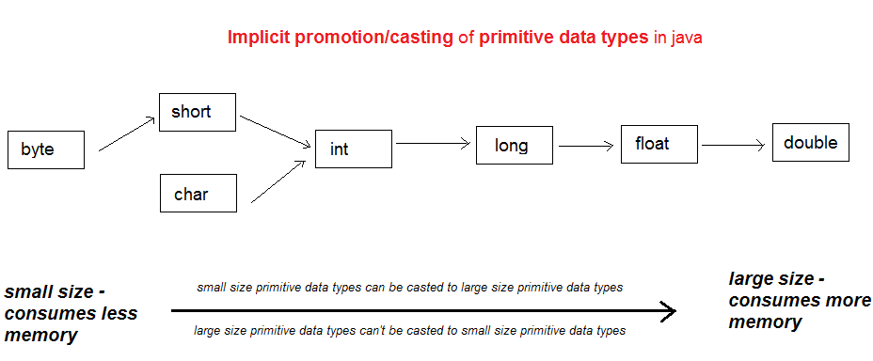

Boolean cannot be casted implicitly or explicitly to any other datatype.
- What are native methods in java?
Native methods are those methods in java, whose implementation is provided by JVM and whose definition is not available for us. For example: clone() method of Object class, start() method of Thread class, etc.
- How a fail-fast iterator throws ConcurrentModificationException?
The collections which uses fail-fast iteratior, they maintain a variable named modificationCount. Whenever the collection is modified, the modificationCount is incrceased. The iterators of these collection maintain a variable named expectedModificationCount. When we create the iterator of these types of collection, the expectedModificationCount is initialized with modificationCount. Whenever, we call any method of iterator, first it is checked that modificationCount and expectedModificationCount are same or not. When we modify the collection using the method of iterator, after the check of equality of modificationCount and expectedModificationCount, if both are same, then the collection is modified and modificationCount and expectedModificationCount both are increased. But, if we modify the collection without using the methods of iterator, then modificationCount will increase but expectedModificationCount will not increase. Then if we call any method of iterator previously created, then the equality check of modificationCount and expectedModificationCount will fail and the iterator will throw the ConcurrentModificationException.
- A pool of strings, initially empty, is maintained privately by the class String. When the intern method is invoked, if the pool already contains a string equal to this String object as determined by the equals(Object) method, then the string from the pool is returned. Otherwise, this String object is added to the pool and a reference to this String object is returned.
- When String is created without new operator, it will be created in string pool. For example:
String s1 = "abc";
When String is created using new operator, it will force JVM to create new string in heap (not in string pool). For example:
String s2 = new String("abc");
When String is created using new operator and intern() method is invoked on it, the reference created will refer to the string in the string pool. For example:
String s5 = new String("abc").intern(); Here, string is created using new operator but intern method has been invoked on it, so s5 will be a reference variable which will refer to “abc” in string pool.
- Neither Hashtable nor ConcurrentHashMap support null keys or values. HashMap allows to store one null key and many null values. Why?
HashTable: To successfully store and retrieve objects from a hashtable, the objects used as keys must implement the hashCode method and the equals method. Since null isn't an object, you can't call .equals() or .hashCode() on it, so the Hashtable can't compute a hash to use it as a key. In HashTable, in put(K key, V value) method, we have key.hashcode() which throws null pointer exception and we have if(value==null){throw new NullPointerException... So, we can’t store null as key or value in HashTable.
HashTable: HashMap is newer, and has more advanced capabilities, which are basically an improvement on the Hashtable functionality. As such, when HashMap was created, it was specifically designed to handle null values as keys and handles them as a special case. HashMap allows null values as it doesn't have any checks like HashTable, while it allows only one null key. This is done with the help of putForNullKey method, which add the value to the 0th index of the internal Array every time the key is provided as null.
ConcurrentHashMap: The main reason that nulls aren't allowed in ConcurrentMaps (ConcurrentHashMaps, ConcurrentSkipListMaps) is that ambiguities that may be just barely tolerable in non-concurrent maps can't be accommodated. The main one is that if map.get(key) returns null, you can't detect whether the key explicitly maps to null vs the key isn't mapped. In a non-concurrent map, you can check this via map.contains(key), but in a concurrent one, the map might have changed between calls.
- java.util.Collections is a utility class which consists of static methods that operate on or return Collection in java.
Methods of java.util.Collections: reverse, shuffle, unmodifiableCollection, min, max, sort, synchronizedCollection,
- Checked exceptions are also called compile-time exceptions and unchecked exceptions are also called run-time exceptions.
- Whether it is checked exception or unchecked exception or error, when they reach to JVM, the stack trace is printed.
- What are the valid combinations of try, catch and finally? What will be the valid combinations with try-with-resources?
For try, catch and finally: try-catch, try-finally and try-catch-finally are valid combinations.

But, catch block in try-with-resources is optional if close() method of AutoCloseable is not able to throw a checked exception. However, if close() can, then a checked exception would need to handled in a normal fashion, either with a catch block, or by throwing from the method that try-with-resources block is in. For example: If your try to create a Connection object in a try-with-resources block, with no subsequent catch block, you will get a compiler error from eclipse: "Unhandled exception type SQLException thrown by automatic close() invocation."
A try-with-resources statement with at least one catch clause and/or a finally clause is called an extended try-with-resources statement. The extended try-with-resources statement allows the catch clause to catch an exception due to the automatic initialization or closing of any resource.
- If multi catch syntax is used to catch subclass and its superclass both (in any sequence), then compilation error will be thrown.
- Java VisualVM tool can be used for profiling of applications to solve the memory leaks.
- A few of the possible OOM messages: Java heap space, PermGen space, Requested array size exceeds VM limit, request <size> bytes for <reason>. Out of swap space?, <reason> <stack trace> (Native method).
- Application Crash without explicit OOM message: This occurs if you’re running native code that doesn’t check for errors returned by memory allocation functions. For example, the malloc system call returns NULL if there is no memory available. If the return from malloc is not checked, then the application might crash due to attempt of dereference of null pointer but its actual cause was out of memory. Depending on the circumstances, this type of issue can be difficult to locate. In some cases, the information from the fatal error log or the crash dump can be helpful.
- Diagnosing Leaks: (the process can be lengthy and iterative.) In most cases, diagnosing memory leaks requires very detailed knowledge of the application in question. The simple strategy for hunting down memory leaks are: Identify symptoms, Enable verbose garbage collection, Enable profiling, Analyze the trace, etc.
- String interning is a method of storing only one copy of each distinct string value in the String class, which must be immutable. Interning strings makes some string processing tasks more time- or space-efficient at the cost of requiring more time when the string is created or interned. The distinct values are stored in a string intern pool.
The single copy of each string is called its 'intern' and is typically looked up by a method of the string class, for example String.intern() in Java.
- You can use the jmap -permgen command to print statistics related to the permanent generation, including information about internalized String instances.
- Be prepare for the following: During my USEQ univ project at D E Shaw, the application was consistently producing this type of OutOfMemoryError. After some investigation, I figured out that the culprit was an array instantiation that was demanding too much memory; in this case, it wasn’t the application’s fault, but rather, the application server was relying on the default heap size, which was too small. I solved the problem by adjusting the JVM’s memory parameters.
- As per rules of method overriding in Java, an overridden method in subclass can not throw Checked Exception which is higher in hierarchy than original method of superclass.
- A fail-fast system is nothing but immediately report any failure that is likely to lead to failure. When a problem occurs, a fail-fast system fails immediately. In Java, we can find this behavior with iterators. Incase, you have called iterator on a collection object, and another thread tries to modify the collection object, then concurrent modification exception will be thrown.
- What are the rules we need to follow in overriding if super class method throws exception ?
- If super class method throws checked or unchecked exceptions its not mandatory to put throws in sub class overridden method.
- If super class method throws exceptions, in sub class if you want to mention throws then use same class or its sub class exception.
- If sub class throws checked exception super class should throw same or super class exception of this.
- A subclass of a normal Singleton class can’t be created because as it contains a private constructor so its default constructor gets hidden and none of its constructor becomes visible to the outside. And to make a subclass, we need at least one visible constructor of superclass (whether it may be default or the other).
Moreover, If you can inherit a class, it's not really a singleton, since each inherited class instance will have superclass instance. If you want to make subclass of your singleton class, you can just make the constructor protected but then the class is not singleton anymore.
- clone() is the protected method of the Object class. If we don’t implement Cloneable interface (means don’t override clone() method) in our class, the clone of the instance of that class can’t be created outside of that class (although it will be possible to create the clone of the instance of that class in the method of that class).
- It is a good idea to prevent cloning in a singleton class explicitly. To prevent cloning on singleton object, we can explicitly throw CloneNotSupportedException exception in overriden clone() method.
- SerialVersionUID is used to ensure that during deserialization the same class (that was used during serialize process) is being deserialized and loaded.
- Consequence of not specifying serialVersionUID is that when you add any field in class then already serialized class will not be able to recover because serialVersionUID generated for new class and for old serialized object will be different. While if you have serialVersionUID provided in your class, then the serialized class will be able to recover if the changes are compatible.
As per Java Serialization specification adding any field or method comes under compatible change and changing class hierarchy or UN-implementing Serializable interfaces come under non compatible changes. For complete list of compatible and non compatible changes I would advise reading Java serialization specification.
See project: SerializationDeserialization. Change serialVersionUID of Employee class and then try to run DeserializeDemo. It will throw an InvalidClassException. Also, try to add a new field in Employee class during deserialization in two conditions: one if serialVersionUID is present and the other when serialVersionUID is not present.
- Static and transient variables are not serialized during java serialization.
Since static variables belong to the class and not to an object they are not the part of the state of object so they are not saved during Java Serialization process as Java Serialization only persist state of object and not object itself.
Transient variables are also not included in java serialization process and are not the part of the object’s serialized state.
- finally will always be called in a method. It will be executed even when return keyword is used in try block or try block throws some exception and it doesn’t have catch block. The only times finally won't be called are:
- if you call System.exit(0) in try block or
- if the JVM crashes first
- If exception is thrown in finally the further statements in finally will not be executed.
- If we have different return statements in all try, catch and finally block, only return of finally will be executed. A return in finally does not pass back the control to the program but returns the value and terminates the method. This is one reason why it's best to avoid using return in finally.
If there is a return statement in the finally block, you can’t have anymore statement below that finally block because it will be unreachable code and a compile time error.
- Java doesn’t allow private field members in an interface. An interface is used for describing an API which is provided by any class implementing the interface. Since an interface from its definition has no state there is no use of declaring private field members in it.
- strictfp is a keyword which can be used with class/function that restricts floating-point calculations by JVM only as per IEEE 754 to ensure portability.
- A method in an interface it is by default abstract to force the implementing class to provide an implementation and is public by default so the implementing class has access to do so.
It is permitted, but discouraged as a matter of style, to redundantly specify the public and/or abstract modifier for a method declared in an interface.
- With methods in interface, protected and private are not permitted. Only public, abstract, default, static and strictfp are permitted.
- Some methods of Executors:
Executors.newFixedThreadPool(8);
Executors.newSingleThreadScheduledExecutor();
- In general, at the top of every important class (which requires logging facility), you should have:
private static final Logger LOGGER = Logger.getLogger( ClassName.class.getName() );
Then, you can just use various facilities of the Logger class.
- Java synchronized keyword cannot be used for constructors and variables.
- PrintStream uses platform's default encoding while with the PrintWriter you can however pass an OutputStreamWriter with a specific encoding.
- HashMap can be synchronized by
Map m = Collections.synchronizeMap(hashMap);
- The volatile keyword can make sure that:
  - The read and write of long and double volatile variables will be atomic,
  - a given variable is read directly from main memory,
  - and always written back from cache to main memory when updated.
- TimerTask is also a Runnable. It implements Runnable. We extends TimerTask class to use in our programs. So, our extended subclass is also a Runnable only.
This TimerTask Runnable is run by the worker named Timer.
- Instead of a map wide lock, ConcurrentHashMap maintains a list of 16 locks by default ( number of locks equal to the initial capacity , which is by default 16) each of which is used to lock on a single bucket of the Map.This indicates that 16 threads (number of threads equal to the concurrency level , which is by default 16) can modify the collection at the same time , given ,each thread works on different bucket. So unlike hashtable, we perform any sort of operation ( update ,delete ,read ,create) without locking on entire map in ConcurrentHashMap.
The concurrency level of the ConcurrentHashMap should be set equal to the expected number of threads going to concurrently update the ConcurrentHashMap.
- A lambda expression can be specified only in a context in which a target type is defined. One of these contexts is created when a lambda expression is assigned to a functional interface reference. Other target type contexts include variable initialization, return statements, and method arguments, to name a few.
- The following will not compile:
iOb2 instanceof Gen2<Integer>
Because, generic type info does not exist at run time. To make it compile, use the wildcard character as follows:
iOb2 instanceof Gen2<?>
- Static methods are inherited in Java but they don't take part in polymorphism. If we attempt to override the static methods they will just hide the superclass static methods instead of overriding them.
- The only difference between StringBuffer and StringBuilder is that StringBuffer is thread-safe where as StringBuilder is not.
- The resource declared in the try statement is implicitly final.
- The try-with-resources statement can be used only with those resources that implement the AutoCloseable interface defined by java.lang. This interface defines the close() method. AutoCloseable is inherited by the Closeable interface in java.io. Both interfaces are implemented by the stream classes. Thus, try-with-resources can be used when working with streams, including file streams.
- Immutable class is a class which once created, it’s contents can not be changed. Immutable objects are the objects whose state can not be changed once constructed. e.g. String class.
- All wrapper classes in java.lang are immutable –
String, Integer, Boolean, Character, Byte, Short, Long, Float, Double, BigDecimal, BigInteger
- ThreadLocal variables in Java are generally private static fields in Classes and maintain its state inside Thread.
- We can prevent a thread from execution by using any of the 3 methods of Thread class:
sleep(),
yield(),
join(),

sleep() causes the thread to definitely stop executing for a given amount of time; if no other thread or process needs to be run, the CPU will be idle (and probably enter a power saving mode). But, in this case, the current thread keeps the monitor. Thread state changes from running to waiting but the current thread keeps the monitor.
yield() basically means that the thread is not doing anything particularly important and if any other threads or processes need to be run, they should. If there is no waiting thread or all the waiting threads have a lower priority then the same thread will continue its execution. In case of yield, thread state changes from running to runnable and give up the monitor.
join() means If any executing thread t1 calls join() on t2 i.e; t2.join() immediately t1 will enter into waiting state until t2 completes its execution.
- run() method of Runnable interface can’t throw checked exceptions while call() method of Callable interface can throw checked exceptions.
- To instantiate an inner class outside the outer class, you must first instantiate the outer class. Then, create the inner object within the outer object with this syntax:
OuterClass.InnerClass innerObject = outerObject.new InnerClass();
To create an object for the static nested class outside the outer class, we can use this syntax:
OuterClass.StaticNestedClass nestedObject = new OuterClass.StaticNestedClass();
To create an object of inner class inside the outer class, we can use this syntax:
InnerClass innerObject = new InnerClass();
- The Level class defines seven levels of logging:
FINEST, FINER, FINE, CONFIG, INFO, WARNING, SEVERE
- All methods and variables declared inside an interface are implicitly public.
Variables declared inside interface are implicitly static and final too, meaning they cannot be changed by the implementing class. They must also be initialized.
An abstract method declared inside an interface can’t be static. If we are making a method declared inside an interface static, then we need to give it an implementation. Final is not allowed with the methods (whether it is abstract or default) declared inside an interface.

VVI: Static interface methods are not inherited by either an implementing class or a subinterface. Like static methods in a class, a static method defined by an interface can be called independently of any object. Thus, no implementation of the interface is necessary, and no instance of the interface is required, in order to call a static method. Instead, a static method is called by specifying the interface name, followed by a period, followed by the method name. Here is the general form:
InterfaceName.staticMethodName
- Constant interface: an interface that only defines constants then writing a class implementing that interface.
You can use interfaces to import shared constants into multiple classes by simply declaring a constant interface.
But don’t use this kind of constant interface until you have a genuine requirement because generally constant interface is considered an inappropriate use of interfaces.
- Static import is a feature introduced in the Java programming language that allows members (fields and methods) defined in a class as public static to be used in Java code without specifying the class in which the field is defined. To use static import, the example of the syntax is:
import static java.lang.System.out;
For more informations:
https://en.wikipedia.org/wiki/Static_import
- With class, only public, abstract & final modifiers are permitted. With interface, only public is permitted.
- The use of word final with an interface is not allowed. When the final keyword appears in a class declaration, it means that the class may never be subclassed or overridden. This prevents over-specialization of a particular class. In some sense, the person who created the class considered any further changes to be tangential to its primary purpose. Interface represent behaviour, rather than implementation, therefore it makes no sense for it to be final.
- Some important concrete byte stream classes in java.io are (add InputStream, OutputStream if required): Buffered, ByteArray, Data, File, Filter, Object, Piped, PushbackInputStream, SequenceInputStream, PrintStream,
- Some important concrete character stream classes in java.io are (add Reader, Writer if required): Buffered, CharArray, InputStreamReader, OutputStreamWriter, File, Filter, String, Piped, PushbackReader, LineNumberReader, PrintWriter,
- Seven general purpose built-in annotations in java: @Retention, @Documented, @Target, @Inherited, @Override, @Deprecated, @SuppressWarnings.
- finally block is called even in case of explicit throw in try or return statement in try,
- Public constructors of Exception class:
Exception(), Exception(String msg),
- To allow chained exceptions, two constructors and two methods were added to Throwable:
- Constructors: Throwable(Throwable causeExc), Throwable(String msg, Throwable causeExc),
- These two constructors have also been added to the Error, Exception, and RuntimeException classes.
- Methods: Throwable getCause( ), Throwable initCause(Throwable causeExc),
- Each multi-catch parameter is implicitly final, it can’t be assigned a new value.
- Implementations of Java may have radically different behavior when it comes to scheduling. Most of the inconsistencies arise when you have threads that are relying on preemptive behavior, instead of cooperatively giving up CPU time. The safest way to obtain predictable, cross-platform behavior with Java is to use threads that voluntarily give up control of the CPU.
- In cases where two threads with the same priority are competing for CPU cycles, the situation is complicated. For operating systems such as Windows, threads of equal priority are time-sliced automatically in round-robin fashion. For other types of operating systems, threads of equal priority must voluntarily yield control to their peers. If they don’t, the other threads will not run. Portability problems can arise from the differences in the way that operating systems context-switch threads of equal priority.
- Once a thread is inside a synchronized method, no other thread can call any other synchronized method on the same object.
- The sleep() method in Thread might throw an InterruptedException, if some other thread wanted to interrupt this sleeping one.
- The join() method in Thread might also throw an InterruptedException.
- wait( ), notify( ), and notifyAll( ) methods can be called only from within a synchronized context.
- getState() method of Thread class is:
Thread.State getState( )
It returns a value of type Thread.State that indicates the state of the thread at the time at which the call was made. State is an enumeration defined by Thread.
States of the thread:
BLOCKED, NEW, RUNNABLE, TERMINATED, TIMED_WAITING, WAITING,
BLOCKED state: A thread that has suspended execution because it is waiting to acquire a lock.
- Important methods of enumeration:
values(),
valuesOf(),
ordinal(),
compareTo(),
equals(),
- Seven general purpose built-in annotations in java: @Retention, @Documented, @Target, @Inherited, @Override, @Deprecated, @SuppressWarnings.
- Of these seven, four are imported from java.lang.annotation: @Retention, @Documented, @Target, and @Inherited. These annotations can be be used only as an annotation to another annotation.
- Three—@Override, @Deprecated, and @SuppressWarnings—are included in java.lang.
- PrintWriter is one of the character-based classes. This line of code creates a PrintWriter that is connected to console output:
// PrintWriter(OutputStream outputStream, boolean flushOnNewline)
PrintWriter pw = new PrintWriter(System.out, true);
pw.println("Printing this.");
pw.close();
close() method of PrintWriter Closes the stream and releases any system resources associated with it. Closing a previously closed stream has no effect.
- PrintWriter writer = new PrintWriter(new OutputStreamWriter(outputStreamObj, "UTF-8"));
Using PrintWriter makes the output internationalizable - because encodings like UTF-8 can be specified. (UTF-8 is a character encoding capable of encoding all possible characters, or code points, defined by Unicode.)
- @see is useful for information about related methods/classes in an API. It will produce a link to the referenced method/code on the documentation. Use it when there is related code that might help the user understand how to use the API.
- static <T extends Comparable<T>, V extends T> boolean isIn(T x, V[] y) {
// The above syntax checks for type mismatch.
Integer nums[] = { 1, 2, 3, 4, 5 };
// Oops! Won't compile! Types must be compatible.
// if(isIn("two", nums))
// System.out.println("two is in strs");
...
}
- A reifiable type is a type whose type information is fully available at runtime. This includes primitives, non-generic types, raw types, and invocations of unbound wildcards.
- Non-reifiable types are types where information has been removed at compile-time by type erasure — invocations of generic types that are not defined as unbounded wildcards.
- Always iterate Java Collections internally by using,
List<Integer> numbers = Arrays.asList(1, 2, 3, 4, 5, 6);
numbers.forEach(System.out::println);

For complex objects:
public static void main(String[] args) {
List<Items> items = Arrays.asList(ob1, ob2, ob3);
items.forEach(MainClass::printItemInfo);
}
static void printItemInfo (Item item) {
...
}
- The "Runnable" is the task to perform. The "Thread" is the worker who is doing this task.
- Java volatile keyword cannot be used with method or class and it can only be used with variable.
- There are many classes in JDK which is implemented using Singleton pattern like java.lang.Runtime which provides getRuntime().
- Executor framework facilitate process of creating Thread pool in java.
- In terms of Java API, thread deadlock can occur in following conditions:
(i) When two threads call Thread.join() on each other.
(ii) When thread A has lock over object a, and waiting for lock over b, and vice versa at the same time.
- In terms of Java API, thread livelock can occur in following conditions:
(i) When all the threads in a program execute Object.wait(0) on an object with zero parameter. The program is live-locked and cannot proceed until one or more threads call Object.notify() or Object.notifyAll() on the relevant objects. Because all the threads are blocked, neither call can be made.
(ii) When all the threads in a program are stuck in infinite loops.
- Thread Scheduler is responsible to allocate CPU to threads in Runnable thread pool and change their state to Running. We can create a thread in java and start it but how the thread states change from Runnable to Running to Blocked depends on the OS implementation of thread scheduler and java doesn’t have full control on that.
- When we call start() function on Thread object, it’s state is changed to Runnable and the control is given to Thread scheduler to finish it’s execution. Whether to run this thread instantly or keep it in runnable thread pool before running it depends on the OS implementation of thread scheduler.
- A running thread can change its state to Runnable, Dead or Blocked depending on time slicing, thread completion of run() method or waiting for some resources.
- Once the thread wait state is over, it’s state is changed to Runnable and it’s moved back to runnable thread pool.
- A monitor is a concept/mechanism that's not limited to the Java Language. Strictly speaking, the two terms monitor and lock do mean different things ... especially if you use them in the way that they were originally intended to be used.
A "lock" is something with acquire and release primitives that maintain certain lock properties; e.g. exclusive use or single writer/multiple reader.
A "monitor" is a mechanism that ensures that only one thread can be executing a given section (or sections) of code at any given time. This can be implemented using a lock (and "condition variables" that allow threads to wait for or send notifications to other threads that the condition is fulfilled), but it is more than just a lock.
- If one were to be pedantic, "monitor" is actually a better term than "lock" for characterizing what Java is providing. But in practice, both terms are used almost interchangeably.
- Every thread has it’s own ThreadLocal variable and they can use it’s get() and set() methods to get the default value or change it’s value local to Thread.
- Concurrent Collection classes support full concurrency of retrievals and adjustable concurrency for updates.
- Profiling is the process of monitoring various JVM level parameters such as Method Execution, Thread Execution, Object Creation and Garbage Collection. It will provide you with a finer view of your target application execution and its resource utilization. There are many tools for profiling of Java applications but they also work on some performance cost. Its better to do profiling in dummy production environment rather than directly in production environment.
- Constructors are nothing more than special methods, and can throw exceptions like any other method. A constructor CAN throw any exception. But if any subclass constructor calls a super class constructor which throws an exception, then the subclass constructor must either catch the exception or throw it.
When a constructor thorws an exception, the object is not created. (See project: ConstructorException)
- With class, only public, abstract & final modifiers are permitted. With interface, only public is permitted.
- An enum type is a special data type that enables for variables to be a set of predefined constants.
- An enumeration is an interface.
- A shutdown hook is an initialized and unstarted thread that gets executed when a JVM shutdown occurs.
- Read and write operations are synchronized in java to guarantee the atomic completion of critical operations.
- In System.out.println(), out is the public static variable of System class and is an instance of PrintStream class. println() method of PrintStream internally calls print() method of PrintStream which is synchronized. Thus, out object of System class is synchronized.
- readLine() method of BufferedReader is also synchronized.
- If singleton class is Serializable, you can serialize the singleton instance. Once it is serialized, you can deserialize it but it will not return the singleton object. To resolve this issue, you need to override the readResolve() method that enforces the singleton. ReadResolve() method is called just after the object is deserialized, so it returns the singleton object.
import java.io.Serializable;
class A implements Serializable{
private static A obj;
private A(){}
public static A getA(){
if (obj == null){
synchronized(A.class){
if (obj == null){
obj = new A();//instance will be created at request time
}
}
}
return obj;
}
protected Object readResolve() {
return getA();
}
}
- Behaviour of char:
char ch1 = 88; // code for X
System.out.println(ch1); //output: X
ch1++;
System.out.println(ch1); //output: Y
- Three bases can be used for integer literals: decimal, octal, hexadecimal.
- Octal values are denoted in Java by a leading zero. Normal decimal numbers cannot have a leading zero. Thus, the seemingly valid value 09 will produce an error from the compiler, since 9 is outside of octal’s 0 to 7 range.
- A more common base for numbers used by programmers is hexadecimal. You signify a hexadecimal constant with a leading zero-x, (0x or 0X). The range of a hexadecimal digit is 0 to 15, so A through F (or a through f ) are substituted for 10 through 15.
- The only difference between StringBuffer and StringBuilder is that StringBuffer is thread-safe where as StringBuilder is not.
- Beginning with JDK 7, you can also specify integer literals using binary. To do so, prefix the value with 0b or 0B. For example, this specifies the decimal value 10 using a binary literal:
int x = 0b1010;
- When a literal value is assigned to a byte or short variable, no error is generated if the literal value is within the range of the target type.
- An integer can also be assigned to a char as long as it is within range.
- Floating-point literals in Java default to double precision. To specify a float literal, you must append an F or f to the constant. You can also explicitly specify a double literal by appending a D or d.
- Characters in Java are indices into the Unicode character set. They are 16-bit values that can be converted into integers and manipulated with the integer operators, such as the addition and subtraction operators.
- For widening conversions, the numeric types, including integer and floating-point types, are compatible with each other. However, there are no automatic conversions from the numeric types to char or boolean. Also, char and boolean are not compatible with each other.
- For switch statements(switch(exp){}), expression must be of type byte, short, int, char, enumeration or String.
- In java, the constructor with no parameters is by default present if and only if no constructor is defined in the class.
- Methods declared as static have several restrictions:
• They can only directly call other static methods.
• They can only directly access static data.
• They cannot refer to this or super in any way.
- A field can be declared as final. You must initialize a final field when it is declared. You can do this in one of two ways: First, you can give it a value when it is declared. Second, you can assign it a value within a constructor.
- In addition to fields, both method parameters and local variables can be declared final.
- There are two types of nested classes: static and non-static.
A static nested class is one that has the static modifier applied. Because it is static, it must access the non-static members of its enclosing class through an object. That is, it cannot refer to non-static members of its enclosing class directly. Because of this restriction, static nested classes are seldom used.
The most important type of nested class is the inner class. An inner class is a non-static nested class. An instance of inner class can exist only within an instance of outer class and has direct access to the methods and fields of its enclosing instance. It has access to all of the variables and methods of its outer class and may refer to them directly in the same way that other non-static members of the outer class do.
- It is possible to define inner classes within any block scope. For example, you can define a nested class within the block defined by a method or even within the body of a for loop.
- Anonymous inner class:
http://www.javatpoint.com/anonymous-inner-class
- A variable-length argument is specified by three periods (...). For example, here is how vaTest( ) is written using a vararg:
static void vaTest(int ... v) {
- There can’t be more than one vararg parameter in any method.
- If a class implements two interfaces that both have the same default method, but the class does not override that method, then an error will result. It is important for that class to override that method.
- An interface can be declared as member of only a top-level class or another interface. Such an interface is called a member interface or a nested interface.
- A nested interface can be declared as public, private, or protected. This differs from a top-level interface, which must either be declared as public or use the default access level.
- A nested interface can be implemented by any class (even by the classes outside the enclosing class or interface).
When a nested interface is used outside of its enclosing scope, it must be qualified by the name of the class or interface of which it is a member. Thus, outside of the class or interface in which a nested interface is declared, its name must be fully qualified.
- The flow of execution stops immediately after the throw statement; any subsequent statements are not executed. The nearest enclosing try block is inspected to see if it has a catch statement that matches the type of exception. If it does find a match, control is transferred to the caller of the method.
- In a multi-catch, each multi-catch parameter is implicitly final.
- When a thread reference is used as an argument to println( ), it displays, in order: the name of the thread, its priority, and the name of its group.
- Classes, methods, fields, parameters, and enum constants are the declarations which can be annotated. Even an annotation can be annotated.
- Whenever you are using a single-member annotation, the name of that member must be value.
- Advantages of try-with-resource: In general, when a try block executes, it is possible that an exception inside the try block will lead to another exception that occurs when the resource is closed in a finally clause. In the case of a “normal” try statement, the original exception is lost, being preempted by the second exception. However, when using try-with-resources, the second exception is suppressed. It is not, however, lost. Instead, it is added to the list of suppressed exceptions associated with the first exception. The list of suppressed exceptions can be obtained by using the getSuppressed( ) method defined by Throwable.
- In addition to using a class type as a bound, you can also use an interface type. In fact, you can specify multiple interfaces as bounds. Furthermore, a bound can include both a class type and one or more interfaces. In this case, the class type must be specified first. When a bound includes an interface type, only type arguments that implement that interface are legal. When specifying a bound that has a class and an interface, or multiple interfaces, use the & operator to connect them. For example,
class Gen<T extends MyClass & MyInterface> { // ...
- For wildcards, lower bound can also be declared by adding super clause to the wildcard declaration. Lower bound can’t be applied for class declaration.
- It is also possible for constructors to be generic, even if their class is not.
- Primitive type double can be cast into int through explicit conversion. Primitive type int can be cast into double automatically. But, neither Integer can be cast into Double nor Double can be cast into Integer (even through explicit conversion).
- Erasure means replacing type parameters with their bound type, which is Object if no explicit bound is specified, and then applying the appropriate casts (as determined by the type arguments) to maintain type compatibility with the types specified by the type arguments. This approach to generics means that no type parameters exist at run time.
- A generic class cannot declare a static variable of parametrized type.
- A static method of a generic class cannot return a parametrized type.
- We can’t create an array of type-specific generic references, because it can lead a loss of type safety.
- A generic class cannot extend Throwable. This means that you cannot create generic exception classes.
- When a lambda expression occurs in a target type context, an instance of a class is automatically created that implements the functional interface, with the lambda expression defining the behavior of the abstract method declared by the functional interface. When that method is called through the target, the lambda expression is executed. Thus, a lambda expression gives us a way to transform a code segment into an object.
- In general, at the top of every important class (which requires logging facility), you should have:
private static final Logger LOGGER = Logger.getLogger( ClassName.class.getName() );
Then, you can just use various facilities of the Logger class.
- Only a final or effectively final local variable can be used inside a lambda. This is called variable capture. Similar rules on variable use apply in the body of an inner class.
The restriction to effectively final variables prohibits access to dynamically-changing local variables, whose capture would likely introduce concurrency problems. Compared to the final restriction, it reduces the clerical burden on programmers.
- A functional interface must contain a method that takes a single int parameter if it is to be used to refer to an array constructor.
- java.util.function provides several predefined functional interfaces such as, UnaryOperator<T>, BinaryOperator<T>, Consumer<T>, Supplier<T>, Function<T, R>, Predicate<T>, etc.
- Situations in which addShutdownHook() should be used:
- your program had created many temporary files in filesystem you want to delete it;
- you need to send a distress signal to another process/machine before terminating;
- execute any clean-up actions, logging or after-error actions on unexpected behaviours.
- The Level class defines seven levels of logging:
FINEST, FINER, FINE, CONFIG, INFO, WARNING, SEVERE
- A class that implements the Iterable can be used with the new for-loop.
List list = new ArrayList();
for(Object o : list){
//do something o;
}
- The equals() method is a very important method which should be implemented well in the class whose objects are going to be stored in the collection. This method is used to search for a particular element.
- The hashCode() method of the objects are used when you insert them into a HashTable, HashMap or HashSet. A combination of the hashCode() and equals() methods are used when looking up the objects in a hashtable.
- Generally don’t override finalize() method. If you find it important in some condition, then use the below template for finalize method:
@Override
protected void finalize() throws Throwable {
try{
//release resources here
}catch(Throwable t) {
throw t;
}finally{
super.finalize();
}
}
- HashMap can be synchronized by
Map m = Collections.synchronizeMap(hashMap);
- The ExecuterService class provides a method, e.g. execute(Runnable r) to add a new Runnable object to the work queue.
- If you submit a Callable object to an Executor, the framework returns an object of type java.util.concurrent.Future.
- Approximate implementation of incrementAndGet() method of AtomicInteger:
public class Counter {
private int value = 0;
// ...
public int incrementAndGetApproximation() {
int oldValue = value;
while (!value.compareAndSet(oldValue, oldValue+1)) {
oldValue = value;
}
return oldValue+1;
}
}
- HashMap allows null values as key and value whereas Hashtable doesn't allow null keys or null values.
- You can interrupt a Thread with the interrupt() method. This method interrupt the thread. If the thread is sleeping or joining another Thread, an InterruptedException is thrown. You have to know that if the thread was sleeping or joining, the interrupted status of the Thread will be cleared.
- BlockingQueue doesn’t accept null values and throw NullPointerException if you try to store null value in it.
- Java synchronized keyword cannot be used for constructors and variables.
- Static synchronized method and non static synchronized method will not block each other.
- ThreadLocal variables in Java are generally private static fields in Classes and maintain its state inside Thread.
- A process is a self contained execution environment. Thread is a single task of execution within the process. Thread requires less resources to be created and to exist in the process, thread shares the process resources.
- Context Switching is the process of storing and restoring of CPU state so that Thread execution can be resumed from the same point at a later point of time.
- Thread dump is list of all the threads active in the JVM, thread dumps are very helpful in analyzing bottlenecks in the application and analyzing deadlock situations. There are many ways using which we can generate Thread dump – Using Profiler, Kill -3 command, jstack tool etc. I prefer jstack tool to generate thread dump of a program because it’s easy to use and comes with JDK installation.
- BlockingQueue implementations are thread-safe. All queuing methods are atomic in nature and use internal locks or other forms of concurrency control.
- run() method of Runnable interface can’t throw checked exceptions while call() method of Callable interface can throw checked exceptions.
- Immutable class is a class which once created, it’s contents can not be changed. Immutable objects are the objects whose state can not be changed once constructed. e.g. String class.
- All wrapper classes in java.lang are immutable –
String, Integer, Boolean, Character, Byte, Short, Long, Float, Double, BigDecimal, BigInteger.
- How to create an immutable class?
To create an immutable class following steps should be followed:
- Make the class final.
- Set the values of properties using constructor only.
- Make the properties of the class final and private.
- Do not provide any setters for these properties.
- If the instance fields include references to mutable objects, don't allow those objects to be changed:
A. Don't provide methods that modify the mutable objects.
B. Don't share references to the mutable objects. Never store references to external, mutable objects passed to the constructor; if necessary, create copies, and store references to the copies. Similarly, create copies of your internal mutable objects when necessary to avoid returning the originals in your methods.
- Stack overflow is an example of error.
- We can prevent a thread from execution by using any of the 3 methods of Thread class:
sleep(),
yield(),
join(),

sleep() causes the thread to definitely stop executing for a given amount of time; if no other thread or process needs to be run, the CPU will be idle (and probably enter a power saving mode). But, in this case, the current thread keeps the monitor.
yield() basically means that the thread is not doing anything particularly important and if any other threads or processes need to be run, they should. If there is no waiting thread or all the waiting threads have a lower priority then the same thread will continue its execution. Otherwise, the current thread will continue to run.
join() means If any executing thread t1 calls join() on t2 i.e; t2.join() immediately t1 will enter into waiting state until t2 completes its execution.
- The only difference between StringBuffer and StringBuilder is that StringBuffer is thread-safe where as StringBuilder is not.
- PrintStream uses platform's default encoding while with the PrintWriter you can however pass an OutputStreamWriter with a specific encoding.
- The resource declared in the try statement is implicitly final.
- The try-with-resources statement can be used only with those resources that implement the AutoCloseable interface defined by java.lang. This interface defines the close() method. AutoCloseable is inherited by the Closeable interface in java.io. Both interfaces are implemented by the stream classes. Thus, try-with-resources can be used when working with streams, including file streams.
- The following will not compile:
iOb2 instanceof Gen2<Integer>
Because, generic type info does not exist at run time. To make it compile, use the wildcard character as follows:
iOb2 instanceof Gen2<?>
- A lambda expression can be specified only in a context in which a target type is defined. One of these contexts is created when a lambda expression is assigned to a functional interface reference. Other target type contexts include variable initialization, return statements, and method arguments, to name a few.
- In general, the type and number of the lambda expression’s parameters must be compatible with the method’s parameters; the return types must be compatible; and any exceptions thrown by the lambda expression must be acceptable to the method.
- To pass a lambda expression as an argument, the type of the parameter receiving the lambda expression argument must be of a functional interface type compatible with the lambda.
- Instead of a map wide lock, ConcurrentHashMap maintains a list of 16 locks by default ( number of locks equal to the initial capacity , which is by default 16) each of which is used to lock on a single bucket of the Map.This indicates that 16 threads (number of threads equal to the concurrency level , which is by default 16) can modify the collection at the same time , given ,each thread works on different bucket. So unlike hashtable, we perform any sort of operation ( update ,delete ,read ,create) without locking on entire map in ConcurrentHashMap.
The concurrency level of the ConcurrentHashMap should be set equal to the expected number of threads going to concurrently update the ConcurrentHashMap.
- TimerTask is also a Runnable. It implements Runnable. We extends TimerTask class to use in our programs. So, our extended subclass is also a Runnable only.
This TimerTask Runnable is run by the worker named Timer.
- HashCode() and equals() methods contract:
- If you override one, then you should override the other.
- Always use same attributes of an object to generate hashCode() and equals() both.
- hashCode() must be consistent (it should be same for the lifetime of the object).
- Whenever a.equals(b), then a.hashCode() must be same as b.hashCode().
- Static methods are inherited in Java but they don't take part in polymorphism. If we attempt to override the static methods they will just hide the superclass static methods instead of overriding them.
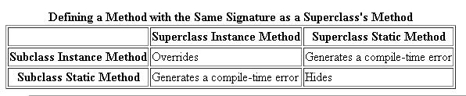
This can be understood by the following program:
class Animal {
public static void testClassMethod() {
System.out.println("Class" + " method in Animal.");
}
public void testInstanceMethod() {
System.out.println("Instance " + " method in Animal.");
}
}
public class Cat extends Animal {
public static void testClassMethod() {
System.out.println("The class method" + " in Cat.");
}
public void testInstanceMethod() {
System.out.println("The instance method" + " in Cat.");
}

public static void main(String[] args) {
Cat myCat = new Cat();
Animal myAnimal = myCat;
myAnimal.testInstanceMethod();
myAnimal.testClassMethod();
myCat.testClassMethod();
}
}

The output of the program is:
The instance method in Cat.
Class method in Animal.
The class method in Cat.

Over-riding basically supports late binding . Therefore, which method will be called is decided at run time.It is for non-static methods. Hiding is for all other members (static methods , instance members, static members). It is based on the early binding . More clearly , the method or member to be called or used is decided during compile time.
In the above example, the call to myAnimal.testInstanceMethod() is resolved at runtime, but the calls to myAnimal.testClassMethod() and myCat.testClassMethod() is resolved at compile time only.

So, if the question is, can we override static methods in java, the answer will be ‘no’.
- Layers in OSI model: PDNTSPA
- If you want to provide common, implemented functionality among all implementations of your component, use an abstract class. Abstract classes allow you to partially implement your class, whereas interfaces contain no implementation for any members.
- If you have overridden the hashCode() method , still you can get the original hashCode of a particular object by using:
System.identityHashCode(obj);
If the Object.hashCode() method is not overridden, then it calls System.identityHashCode(obj) method internally which also returns an integer. The exact behavior of System.identityHashCode(obj) depends on the JVM implementation. That integer returned by identityHashCode may be related to the machine address for the object, or it may not be. The value returned by identityHashCode() is guaranteed not to change for the lifetime of the object. This means that of the GC relocates an object (after an identityHashCode() call) then it cannot use the new object address as the identity hashcode.
- The volatile keyword can make sure that a given variable is read directly from main memory, and always written back from cache to main memory when updated.
- In the hashCode() implementation written by Eclipse IDE, prime number 31 is used. A nice property of 31 is that the multiplication can be replaced by a shift and a subtraction for better performance: 31 * i == (i << 5) - i. Modern VMs do this sort of optimization automatically.
- A [] arr=new A[10];
Here, an array of ten references gets created, and each reference gets set to null. There are no instances of A created by this code.
- A method in an interface it is by default abstract to force the implementing class to provide an implementation and is public by default so the implementing class has access to do so.
It is permitted, but discouraged as a matter of style, to redundantly specify the public and/or abstract modifier for a method declared in an interface.
- A shutdown hook is simply an initialized but unstarted thread. When the virtual machine begins its shutdown sequence it will start all registered shutdown hooks in some unspecified order and let them run concurrently. When all the hooks have finished it will then run all uninvoked finalizers if finalization-on-exit has been enabled. Finally, the virtual machine will halt.
Note that daemon threads will continue to run during the shutdown sequence, as will non-daemon threads if shutdown was initiated by invoking the exit method.
- println() methods are overloaded for different data types for example, int, char, Objects, etc. These methods internally call corresponding print() method of PrintStream. These print() methods internally call write(String str) method by passing everything as the string to this write method. For example:
public void print(char c) {
write(String.valueOf(c));
}
public void print(Object obj) {
write(String.valueOf(obj));
}
These write() methods internally uses write() method of BufferedWriter.
- The only difference between StringBuffer and StringBuilder is that StringBuffer is thread-safe where as StringBuilder is not.
- Layers in OSI model: PDNTSPA
- In general, at the top of every important class (which requires logging facility), you should have:
private static final Logger LOGGER = Logger.getLogger( ClassName.class.getName() );
Then, you can just use various facilities of the Logger class.
- SatohesSome methods of Executors:
Executors.newFixedThreadPool(8);
Executors.newSingleThreadScheduledExecutor();
- With methods in interface, protected and private are not permitted. Only public, abstract, default, static and strictfp are permitted.
- strictfp is a keyword which can be used with class/function that restricts floating-point calculations by JVM only as per IEEE 754 to ensure portability.
- Java doesn’t allow private field members in an interface. An interface is used for describing an API which is provided by any class implementing the interface. Since an interface from its definition has no state there is no use of declaring private field members in it.
- SerialVersionUID is used to ensure that during deserialization the same class (that was used during serialize process) is being deserialized and loaded.
- Consequence of not specifying serialVersionUID is that when you add any field in class then already serialized class will not be able to recover because serialVersionUID generated for new class and for old serialized object will be different. While if you have serialVersionUID provided in your class, then the serialized class will be able to recover if the changes are compatible.
As per Java Serialization specification adding any field or method comes under compatible change and changing class hierarchy or UN-implementing Serializable interfaces come under non compatible changes. For complete list of compatible and non compatible changes I would advise reading Java serialization specification.
See project: SerializationDeserialization. Change serialVersionUID of Employee class and then try to run DeserializeDemo. It will throw an InvalidClassException. Also, try to add a new field in Employee class during deserialization in two conditions: one if serialVersionUID is present and the other when serialVersionUID is not present.
- Static and transient variables are not serialized during java serialization.
Since static variables belong to the class and not to an object they are not the part of the state of object so they are not saved during Java Serialization process as Java Serialization only persist state of object and not object itself.
Transient variables are also not included in java serialization process and are not the part of the object’s serialized state.
- As per rules of method overriding in Java, an overridden method in subclass can not throw Checked Exception which is higher in hierarchy than original method of superclass.
- A few of the possible OOM messages: Java heap space, PermGen space, Requested array size exceeds VM limit, request <size> bytes for <reason>. Out of swap space?, <reason> <stack trace> (Native method).
- Application Crash without explicit OOM message: This occurs if you’re running native code that doesn’t check for errors returned by memory allocation functions. For example, the malloc system call returns NULL if there is no memory available. If the return from malloc is not checked, then the application might crash due to attempt of dereference of null pointer but its actual cause was out of memory. Depending on the circumstances, this type of issue can be difficult to locate. In some cases, the information from the fatal error log or the crash dump can be helpful.
- Diagnosing Leaks: (the process can be lengthy and iterative.) In most cases, diagnosing memory leaks requires very detailed knowledge of the application in question. The simple strategy for hunting down memory leaks are: Identify symptoms, Enable verbose garbage collection, Enable profiling, Analyze the trace, etc.
- Be prepare for the following: During my USEQ univ project at D E Shaw, the application was consistently producing this type of OutOfMemoryError. After some investigation, I figured out that the culprit was an array instantiation that was demanding too much memory; in this case, it wasn’t the application’s fault, but rather, the application server was relying on the default heap size, which was too small. I solved the problem by adjusting the JVM’s memory parameters.
- String interning is a method of storing only one copy of each distinct string value in the String class, which must be immutable. Interning strings makes some string processing tasks more time- or space-efficient at the cost of requiring more time when the string is created or interned. The distinct values are stored in a string intern pool.
The single copy of each string is called its 'intern' and is typically looked up by a method of the string class, for example String.intern() in Java.
- You can use the jmap -permgen command to print statistics related to the permanent generation, including information about internalized String instances.
- Java VisualVM tool can be used for profiling of applications to solve the memory leaks.
- What are the rules we need to follow in overriding if super class method throws exception ?
- If super class method throws checked or unchecked exceptions its not mandatory to put throws in sub class overridden method.
- If super class method throws exceptions, in sub class if you want to mention throws then use same class or its sub class exception.
- If sub class throws checked exception super class should throw same or super class exception of this.
- If multi catch syntax is used to catch subclass and its superclass both (in any sequence), then compilation error will be thrown.
- What are the valid combinations of try, catch and finally? What will be the valid combinations with try-with-resources?
For try, catch and finally: try-catch, try-finally and try-catch-finally are valid combinations.

But, catch block in try-with-resources is optional if close() method of AutoCloseable is not able to throw a checked exception. However, if close() can, then a checked exception would need to handled in a normal fashion, either with a catch block, or by throwing from the method that try-with-resources block is in. For example: If your try to create a Connection object in a try-with-resources block, with no subsequent catch block, you will get a compiler error from eclipse: "Unhandled exception type SQLException thrown by automatic close() invocation."
A try-with-resources statement with at least one catch clause and/or a finally clause is called an extended try-with-resources statement. The extended try-with-resources statement allows the catch clause to catch an exception due to the automatic initialization or closing of any resource.
- Checked exceptions are also called compile-time exceptions and unchecked exceptions are also called run-time exceptions.
- java.util.Collections is a utility class which consists of static methods that operate on or return Collection in java.
Methods of java.util.Collections: reverse, shuffle, unmodifiableCollection, min, max, sort, synchronizedCollection,

Output related interview questions
(Question no: 1, 2, 7, 9, 12, 14, 24, 26, 27, 32):
http://www.javamadesoeasy.com/2015/05/exceptions-top-60-interview-questions_75.html

(Question no: 2, 3, 4, 5, 6, 7, 8, 9, 11, 15, 18, 25):
http://www.javamadesoeasy.com/2015/07/collection-top-100-important-interview.html

29: Arrays.binarySearch() gives –1 because the array provided is not sorted in ascending order.
48: make changes in the program(first add 2, then 1) and try to understand priority queue functioning.
(Question no: 26, 29, 30, 36, 38, 42, 43, 44, 46, 47, 48, ):
http://www.javamadesoeasy.com/2015/07/collection-top-100-important-interview45.html

65, 67: sleep() is a static method but wait() is not a static method.
68: A thread can also be passed to the constructor of other thread in place of runnable because thread is also a runnable.
73: because the new MyClass created in the Thread constructor have obj2 null.
(Question no: 63, 65, 67, 68, 69, 73, 75, 76, 80, 81, 82)
http://www.javamadesoeasy.com/2015/03/threads-top-75-interview-questions-and_10.html

(Question no: 47, 48)
http://www.javamadesoeasy.com/2015/03/thread-concurrency-top-50-interview.html

